Library Management System - Project Part E: Physical Database Design

EECS447: Database Systems
Team Name: ASYNCLIB
Team Members: Nick, Ashton, Cole, Sean, Yadhunath
Professor: Hossein Saiedian
Semester: Fall 2025

Revisions
Version: 1.12

Version | Date | Author | Description
1.12 | 10/31/25 | Nick, Ashton, Cole, Sean, Yadhunath | Defining the Database in PostgreSQL.
1.13 | 11/7/25 | Nick, Ashton, Cole, Sean, Yadhunath | Creating the data to be imported into the Library Database.
1.14 | 11/12/25 | Nick, Ashton, Cole, Sean, Yadhunath | Creating SQL DDL Queries to add the data that was created.

Project Overview:

This Library Management System (LMS) project aims to efficiently manage extensive book information, memberships, clientele, profiles, and accounts. Its database consolidates a vast amount of data, presenting it through an intuitive and easily navigable interface for user convenience.

Scope:

- This project focuses on developing a comprehensive resource management system for books and magazines. It will store key details such as title, author, ISBN/issue number, publication date, genre, and availability.

- Additionally, the system will feature a client and membership management component. This will include unique IDs, contact information, various membership categories (regular, student, senior, none), and defined borrowing restrictions.

- A tracking system will be implemented to manage borrowed, returned, and reserved media. This system will record timestamps, client details, and enforce rules regarding borrowing limits and late return fees.

- Finally, a user interface will be developed to enable staff to efficiently manage operations. This includes checking out and returning items, adding new resources, managing client accounts, calculating fines, and viewing both resource availability and client profiles.

Glossary
- Primary Key: A candidate key that is chosen by the database designer to uniquely identify each tuple in a relation. It is a minimal key, meaning it uniquely identifies a tuple but no proper subset of its attributes can uniquely identify a tuple.
- Foreign Key: A foreign key is a field (or collection of fields) in one table that uniquely identifies a row of another table.
- Relationship: An association between two or more entities or tables in a database that represents how these entities are connected.

Platform:
Our team selected PostgreSQL as our database product. Our team's familiarity with PostgreSQL and the portability and accessibility of the product were contributing factors to the selection of PostgreSQL as our database product.

Code:

TYPES:

CREATE TYPE media_type AS ENUM ('book','media','magazine');
CREATE TYPE membership_type AS ENUM ('student','educator','public','staff');
CREATE TYPE availability AS ENUM ('checked_out','reserved','available');

RELATIONS (TABLES):

CREATE TABLE Reservations (
item_id int PRIMARY KEY REFERENCES items(item_id) ON DELETE CASCADE,
user_id int REFERENCES client(clid),
date_of_reservation TIMESTAMP DEFAULT NOW()
);

CREATE TABLE Borrowing (
item_id int PRIMARY KEY REFERENCES items(item_id) ON DELETE CASCADE,
user_id int REFERENCES client(clid),
date_of_checkout TIMESTAMP DEFAULT NOW(),
due_date TIMESTAMP
);

CREATE TABLE Clients (
clid SERIAL PRIMARY KEY,
firstname VARCHAR(20) NOT NULL,
lastname VARCHAR(20) NOT NULL,
email VARCHAR(50),
phone BIGINT,
account_status VARCHAR(10) CHECK (account_status IN ('active', 'inactive')),
member_type membership_type REFERENCES Membership_Types(member_type)
);

CREATE TABLE Membership_Types(
member_type membership_type PRIMARY KEY,
checkout_length INT NOT NULL,
late_fee DECIMAL(5,2) NOT NULL,
borrowing_limit INT NOT NULL
);
CREATE TABLE Items (
item_id SERIAL PRIMARY KEY,
title VARCHAR(100) NOT NULL,
publisher VARCHAR(50),
publication_date DATE,
type media_type NOT NULL,
availability availability DEFAULT 'available'
);

CREATE TABLE Books(
genre VARCHAR(20),
tem_id INT REFERENCES Items(item_id),
author_firstname VARCHAR(50),
author_lastname VARCHAR(50),
ISBN INT
);

CREATE TABLE Media (
item_id INT PRIMARY KEY REFERENCES Items(item_id),
director_first VARCHAR(50),
director_last VARCHAR(50)
);

CREATE TABLE Magazine (
item_id INT PRIMARY KEY REFERENCES Items(item_id),
issue_number INT NOT NULL
);

VIEWS:

CREATE VIEW member_permissions AS
SELECT
c.clid,
c.firstname AS client_firstname,
c.lastname AS client_lastname,
mt.member_type,
mt.late_fee,
mt.borrowing_limit
FROM Clients c
JOIN Membership_Types mt
ON c.member_type = mt.member_type;

CREATE VIEW late_items AS
SELECT
c.clid,
c.firstname || ' ' || c.lastname AS client_name,
i.title AS item_title,
b.date_of_checkout,
m.checkout_length,
(b.date_of_checkout + m.checkout_length * INTERVAL '1 day') AS due_date
FROM borrowing AS b
JOIN clients AS c
ON b.client_id = c.clid
JOIN membership_types AS m
ON c.member_type = m.member_type
JOIN items AS i
ON b.item_id = i.item_id
WHERE (b.date_of_checkout + m.checkout_length * INTERVAL '1 day') < CURRENT_DATE;

COMMON QUERIES:

SELECT
i.title,
i.publisher,
b.author_firstname,
b.author_lastname,
i.publication_date,
b.isbn, i.availability
FROM items as i
NATURAL JOIN books as b

Table Contents:
Items:
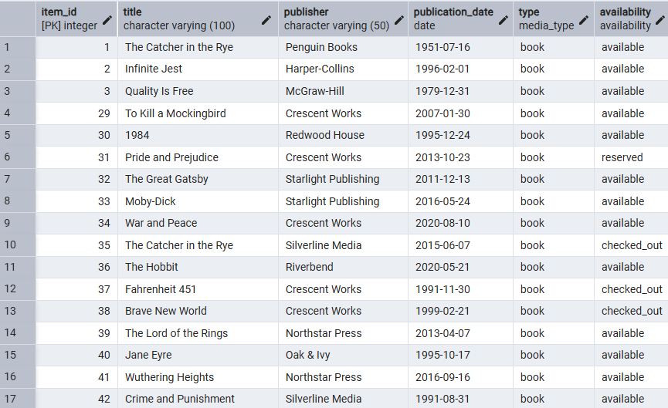
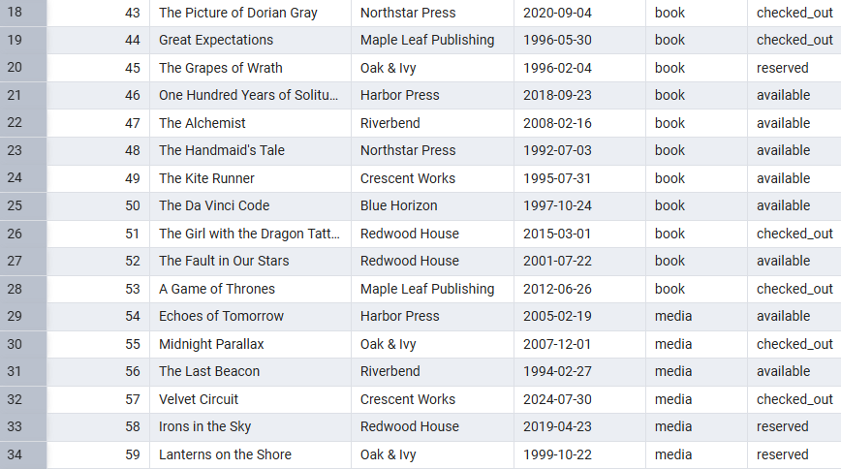
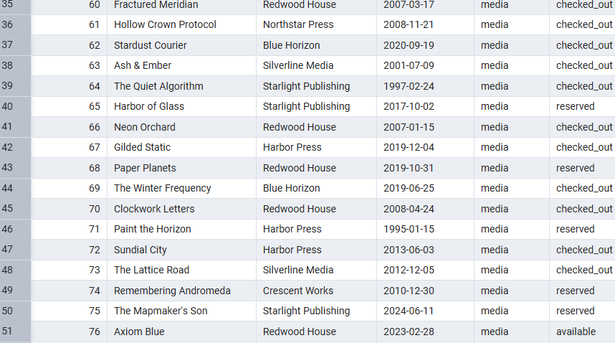
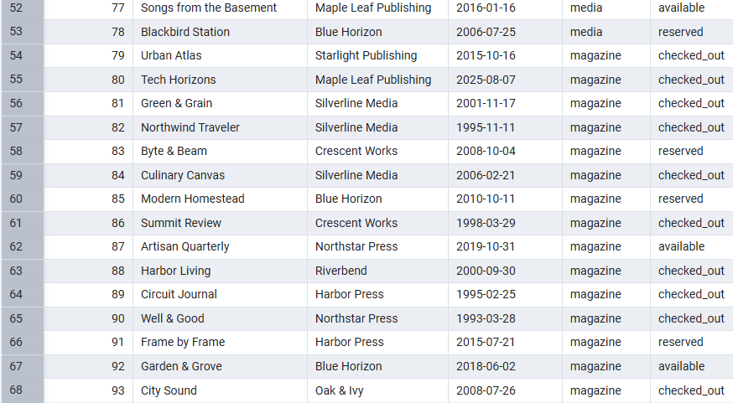
Books:
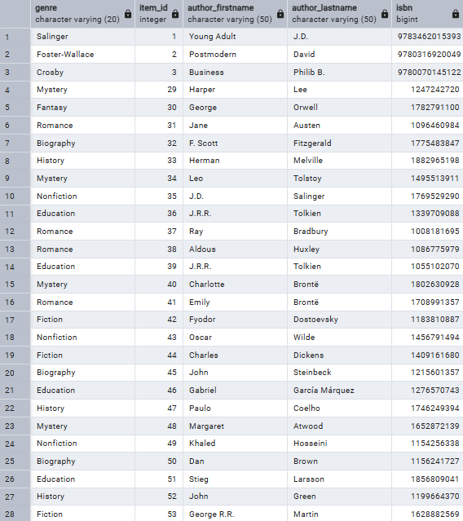

Media:
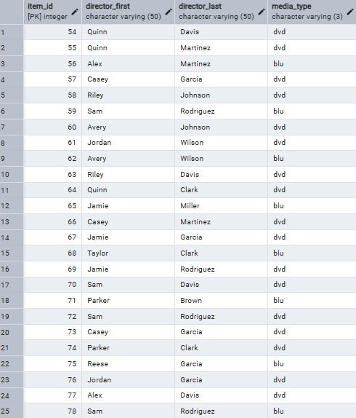

Magazines:
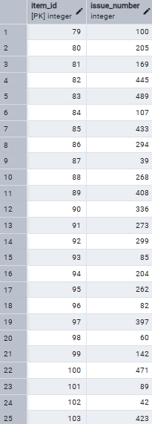
Clients:
